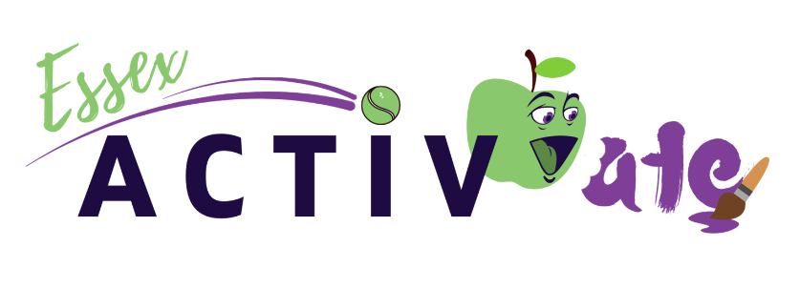

Winter ActivAte – Family Experience Grant Funding
Active Essex has allocated additional funding as part of its Winter ActivAte 2021 programme. This funding is specifically for statutory agencies, organisations, charities and community groups who provide direct support and services to families with school aged children and their families within Essex and Thurrock.
The funding available is to enable the purchased of family experience and/or tickets for local attractions and events taking place between during the December Christmas school holidays for the families you support, to attend and enjoy. All family experiences must include the provision of food. This can be given as a separate meal ticket or a packed lunch. (please contact your Active Essex Locality Officer for further advice)
We ask for those who work with our target audience to complete an application form or get in touch with your quadrant Locality Officer to discuss further how this funding can support you the families you work directly with.
Funding is up to £2,500 per a quadrant (maximum four quadrants per an application).
See application for funding criteria for full details.
We are limited and unable to support everyone so please submit your application at your earliest convenience.
What is Essex Activate:
Essex ActivAte is the name for the Holiday Activity and Food programme across Essex, run by Active Essex on behalf of Essex County Council and funded through the Department for Education. The programme aims to support the physical and mental wellbeing of primary and secondary school children, through engagement in a wide variety of activities including physical, enrichment, food education and family support.
- The Winter ActivAte additional funding is aimed at agencies, organisations, charities and community groups who provide direct support to children who are in receipt of benefit based free school meals or families on low income and financially struggling, Looked after Children, children experiencing parental offending and/or those who you feel are vulnerable and would benefit from a family experience and quality time together.

Locality Leads
Nic Smith - South Essex Locality Lead and SEND and Mental Wellbeing Lead
nicola.smith5@essex.gov.uk
Chloe Hinds - Mid Essex Locality Lead and Keep Essex Active/ Virtual offer Lead
chloe.hinds@essex.gov.uk
Emma Meek - West Essex Locality Lead and Enrichment Activity Lead
emma.meek@essex.gov.uk
Suzanne Page - North Essex Locality Lead and Families Support Lead



suzanne.page@activeessex.org

